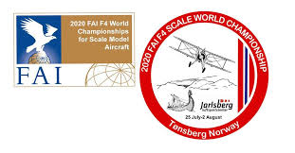

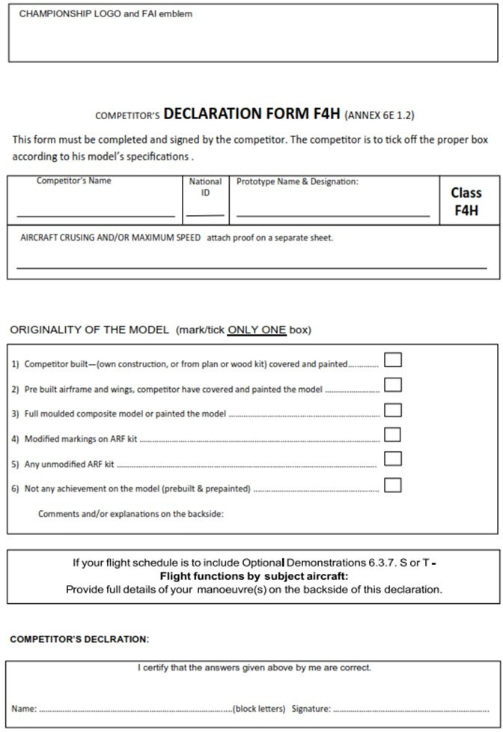

Any additional comments to originality of the Model:

If your flight schedule is to include Optional Demonstrations 6.3.7. S or T – Flight functions by subject aircraft: Provide full details of your manoeuvre(s) here or on a separate sheet.